**Lab04: Hardware - Three Phase Uncontrolled Rectifers**

**Objective:**

The objectives of the lab include:

1. Operation of Half wave rectifier with R and RL loads.
2. Operation of Full wave rectifier with R and RL loads.

**Equipment Required:**

|  |  |
| --- | --- |
| **Model** | **Name** |
| **8311** | Resistive Load |
| **8325-1X** | Smoothing Inductors |
| **8412-1X** | DC Voltmeter/Ammeter |
| **8425** | AC Ammeter |
| **8821-2X** | Power Supply |
| **8840** | Enclosure/Power Supply |
| **8842-1X** | Power Diodes |

**Background:**

**Three-phase rectifier:**

A three-phase rectifier circuit offers several advantages over a single-phase rectifier. Using Figure 1 the operation og such a circuit can be analyzed to fully understand these advantages.

Figure 1. A three-phase rectifier circuit using diodes.

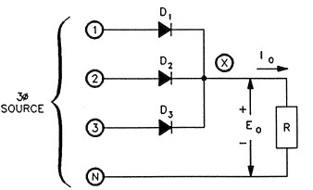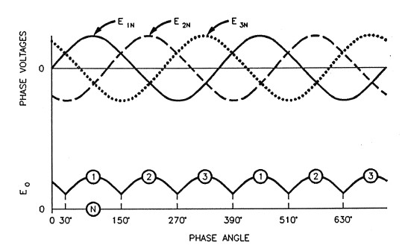

**Half-wave Rectifier:** In Figure 1, the circuit simply consists of three diodes (one for each of the three phases), the three phase source, and the load. The waveforms of the three line voltages and the load voltage are also shown in Figure 1. The output voltage, Eo, is that of point X, measured with respect to the neutral line N. At the origin, the phase angle of E1N is 0o as shown in Figure 1.

Also, **E1N = 0 and D1 does not conduct because the voltage across it is zero.**

E2N < 0 and D2 does not conduct because it is reverse-biased.

E3N > 0 and D3 conducts it is forward-biased.

Since D3 conducts, the voltage at X is the same as that at terminal 3.

**When the phase of E1N exceeds 30o,**

E1N > E3N and D1 conducts because it becomes forward-biased.

E2N < E1N and D2 stays off because of reverse-bias.

E3N < E1N and D3 does not conduct because it becomes reverse-biased.

Since D1 conducts, current flow is now through D1 instead of D3. The voltage at X is the same as that at terminal 1.

**When the phase of E1N has increased by 120o to just over 150o**, E2N > E1N and D2 conducts because it becomes forward-biased.

E3N < E2N and D3 stays off because of reverse-bias.

E1N < E2N and D1 goes off because it becomes reverse-biased.

Since D2 conducts, current flow is now through D1 instead of D3. The voltage at X is the same as that at terminal 2.

**When the phase increases another 120o or just over 270o** E3N > E2N and D3 conducts because it becomes forward-biased.

E1N < E3N and D1 stays off because of reverse-bias.

E2N < E3N and D2 goes off because it becomes reverse-biased.

Since D3 is on again, the voltage at X is the same as that at terminal 3.

When the phase angle increase an extra 90o, we return to the situation at the beginning. The cycle thus repeats itself indefinitely, and the voltage at X contains pulsations or ripple as shown in Figure 1. Notice, however, that the amount of ripple is less than the ripple obtained with a single-phase rectifier. Also the ontime of each diode is 120o, compare to 180o for single phase circuits. These two differences allow using smaller, less powerful semiconductor devices.

The average value of Eo can be calculated with the equation:

Eo = 0.675 ES where ES is the line to line voltage of the source [V ac].

**Three-phase full wave rectifier:**

Figure 2 shows a three-phase, full wave rectifier, also called a three-phase bridge rectifier which uses diodes as the rectifying device.

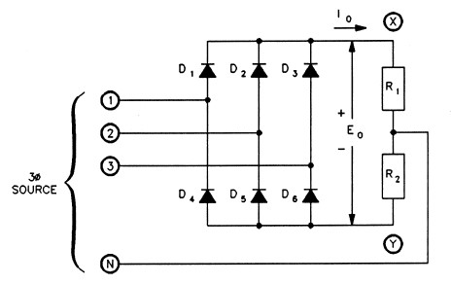

Figure 2. A three-phase full-wave rectifier circuit using diodes.

The rectified output voltage Eo is equal to EXN + ENY  or EXN - EYN. Note that reversal of subscripts makes ENY = -EYN.

This circuit can be considered to be composed of two three-pulse rectifiers. EXN  is the output voltage of the three-pulse rectifier formed by D1, D2 and D3. EYN is of opposite polarity and is the output of the three-pulse rectifier formed by D4, D5, and D6.

The flow of current through R1 is from X towards N. Current flows through R2 from N towards Y. Since the average current flowing to or from N is zero. The N terminal of the three-phase source is not necessary for operation. It is shown here only to simplify the explanation of circuit operation. Figure 3 shows the output voltage waveform.

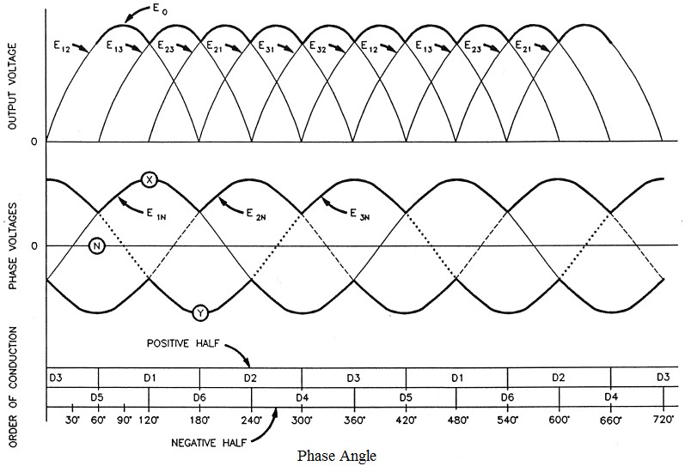

Figure 3. Voltage waveform of the three-phase full-wave rectifier circuit.

As shown in Figure 3, the maximum value of the output voltage is equal to the peak line-to-line voltage. The brick diagram underneath shown the order of conduction and the on-time of the six diodes. From Figure 3, it can be seen that current Io always flows through one diode of the "positive half" D1, D2 or D3 and one diode of the "negative half" D4, D5 or D6 of the bridge rectifier. For example:

If the phase angle is 30o, D3 and D5 conduct. If the phase angle is 90o, D1 and D5 conduct.

The average value of Eo can be calculated with the equation:

Eo = 1.35 ES, where ES is line-to-line voltage of the source [V ac].

Both the three-phase, half-wave and full-wave can be used to supply power to an active load, as in a battery charger. They provide no means for electronically controlling the current.

**Procedure:**

**CAUTION!**

**High voltages are present in this laboratory exercise! Do not make or modify any banana jack connections with the power on unless otherwise specified!**

1. Make sure that the main power switch of the Power Supply is set to the O (OFF) position. Set the voltage control knob to 0.
2. On the power supply, set the 24-V ac power switch to the I (ON) position.

**Three phase, half-wave rectifier:**

1. Connect the modules as shown in Figure 4.

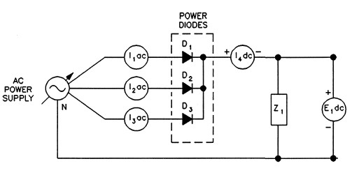

Figure 4.Three-phase, half-wave rectifier circuit.

1. Set the value of Z1 = 550 Ω
2. Make the following settings: On the power supply: Voltage Selector: 4-5

On the oscilloscope:

Channel-1 sensitivity: 2V/DIV (DC coupling)

Channel-2 sensitivity: 0.5V/DIV (DC coupling)

Time Base: 5ms/DIV

Trigger: LINE

1. On the power supply, make sure that the voltage control knob is set to the 0 position then set the main power switch to I (ON). Set the voltage control knob so that the voltage indicated by the power supply voltmeter is equal to 90 % of the nominal line-to-line voltage.

Sketch the voltage and current waveforms in Figure 5. Record the ripple frequency.

Ripple frequency: ______1**50**_________ Hz

1. For the inductive load, use Z1(b) = where R = 550 Ω and L = 0.8 H.
2. Record the output voltage, current, and power of the rectifier circuit in the first row of Table 1.

|  |  |  |  |  |
| --- | --- | --- | --- | --- |
| **Load Z1** | **Output Voltage**  **E1 dc** | **Output Current**  **I1 dc** | **Output Power**  **Po = E1 x I1** | **Conduction**  **Angle** |
|  | **V** | **A** | **W** | **degrees** |
| (a) Resistive | 338.76V | 0.622A | 210.7 W | Refer to graph |
| (b) Inductive | 333.47V | 0.579A | 193.097W | Refer to graph |

Table 1. Measurements for three phase, half wave rectifier.

RESISTIVE

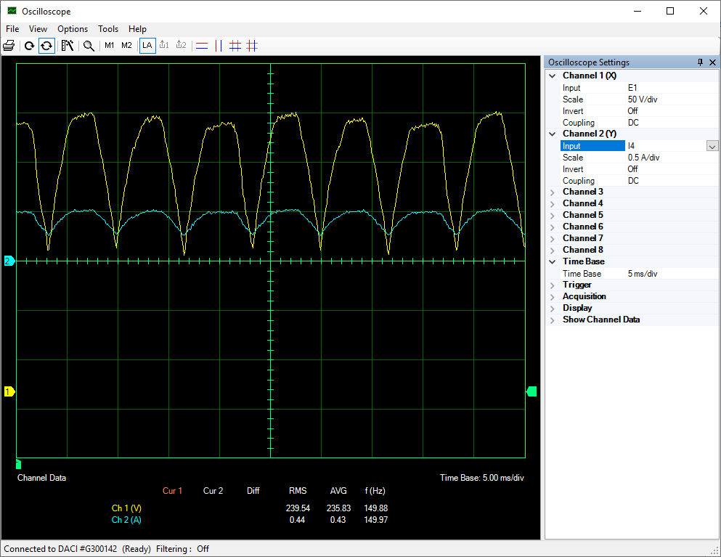

INDUCTIVE LOAD:

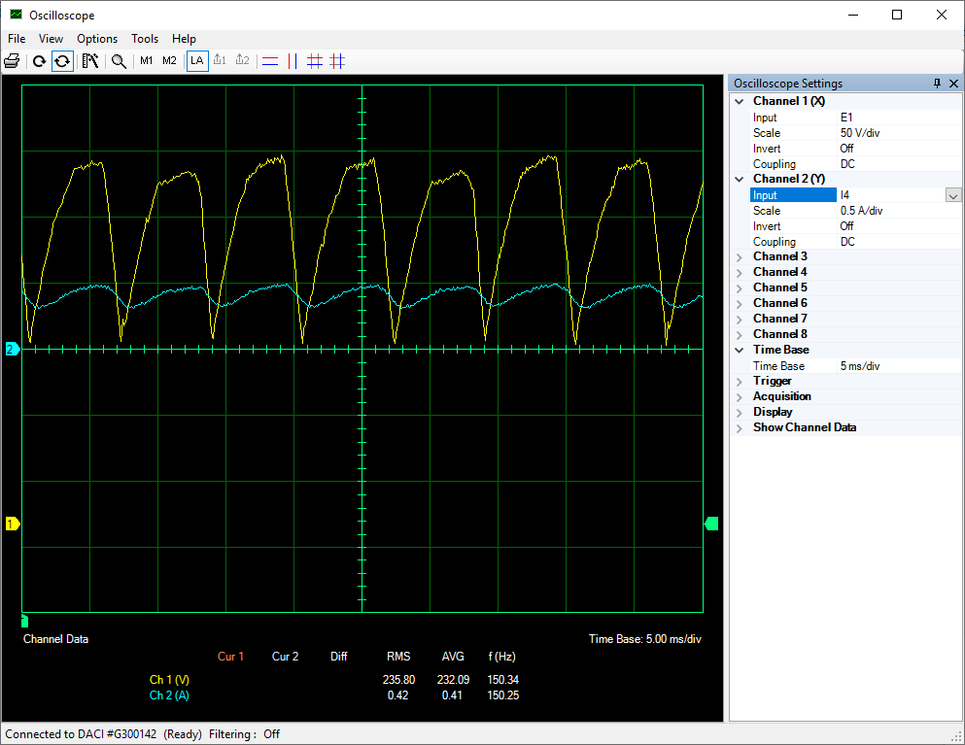

1. To determine the diode conduction angle, connect the current isolator in series with diode D1. Before changing any connections, set the voltage control knob on the power supply to 0, then set the main power switch to O (OFF).
2. With the power off, change the load in the circuit to the inductive load Z1(b) where Z1(b) =

where R = 550 Ω and L = 0.8 H. Repeat the procedure steps necessary to complete Table 1, and Figure 5.

1. **What is the effect of the inductive load on the operation of the circuit?**

|  |
| --- |
| Following are effects that were caused by an inductive load:   * The current varies slowly for the inductive load because it opposes the variation in current. * The current lags the voltage in inductive load.   The conduction angle of the diode is more for inductive load because the inductor must restore the energy which has been supplied by the source. |

1. Compare the output voltage of the circuit to the theoretical value.

Theoretical value: E o = 0.675*ES = 389.87 V dc

Measured value: E1= 333.47 V dc

|  |
| --- |
| **Calculations:**  ERMS = 235.80 V  E s peak= ERMS* V = 333.47 V  Es = E speak * V ( V line-line = sqrt3 * V phase)  Es = 577.502 V |

1. Compare the following characteristics of a three phase, half-wave rectifier to those of a single phase bridge rectifier.

Diode conduction angle:

Ripple frequency :

Average output voltage:

|  |  |  |
| --- | --- | --- |
|  | **Three Phase**  **Half Wave Rectifier** | **Single Phase**  **Full wave Rectifier** |
| **Diode Conduction angle:** | 120◦ | 360◦ |
| **Ripple Frequency** | 150 Hz | 100 Hz |
| **Average output voltage** | 233.5 V | 170 V |

|  |
| --- |
| **Diode Conduction Angle (Half wave three phase rectifier)**  For three-phase uncontrolled rectification, the diodes conduct after every 120 o electrical signal as each phase lags 120 o phase with each other.  half wave three phase rectifier conduction waveform |

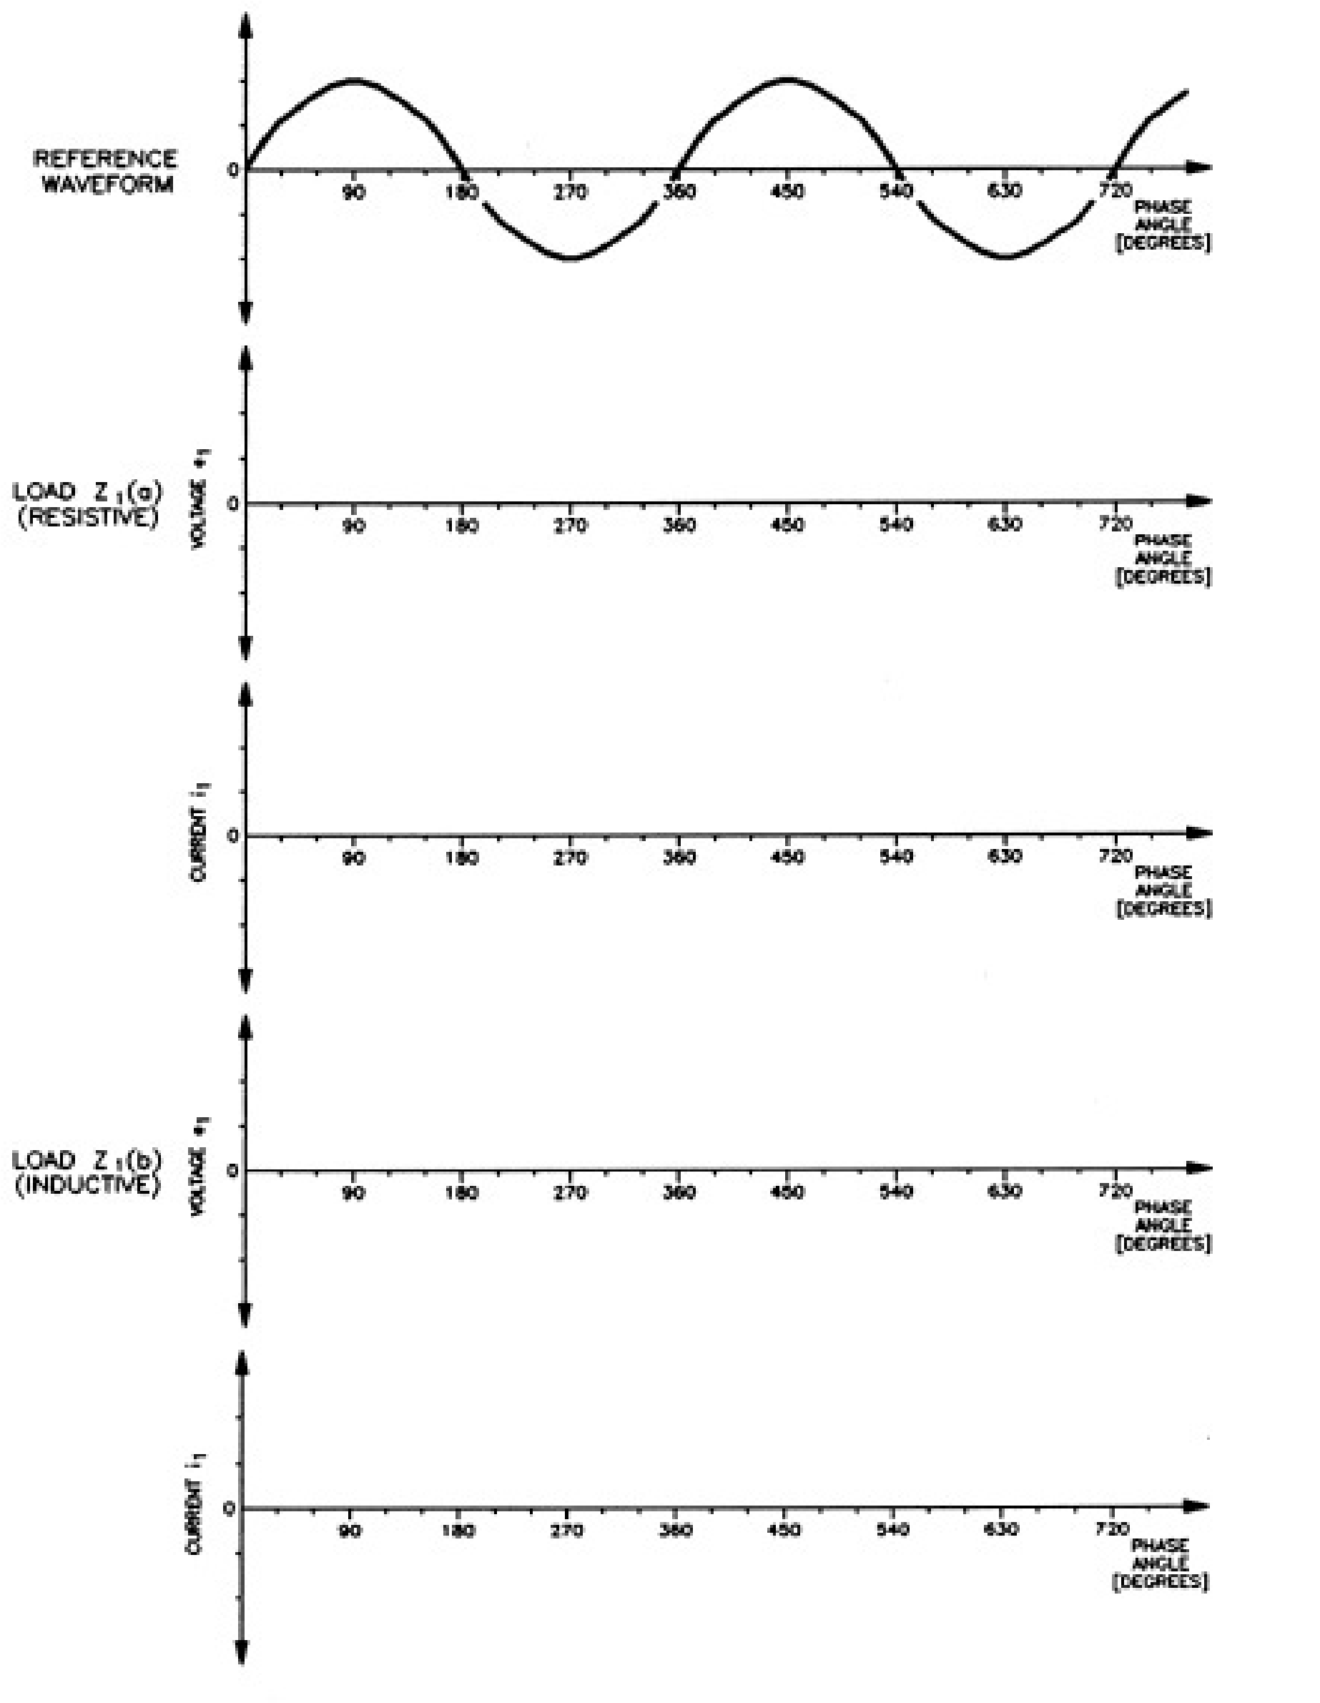

Figure 5. Voltage and current waveforms for three-phase, half-wav rectifier.

**Three-phase, six-pulse rectifier:**

1. Set up the circuit of Figure 6 using the resistive load Z1 (a).

**Note:** Use two resistive load modules in series for Z1. If one module is used the nominal voltage of the module will be greatly exceeded .

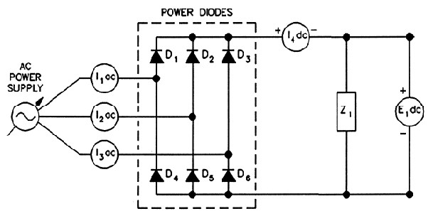

Figure 6. Circuit for observing current and voltage waveforms.

1. Set Z1 (a) =  where R = 550 Ω.

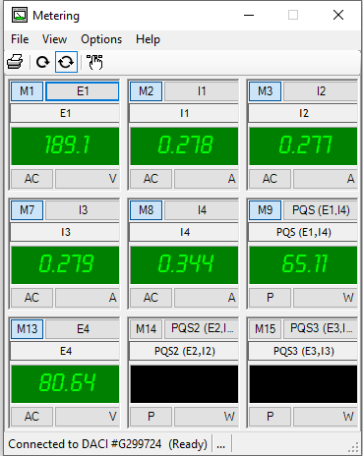

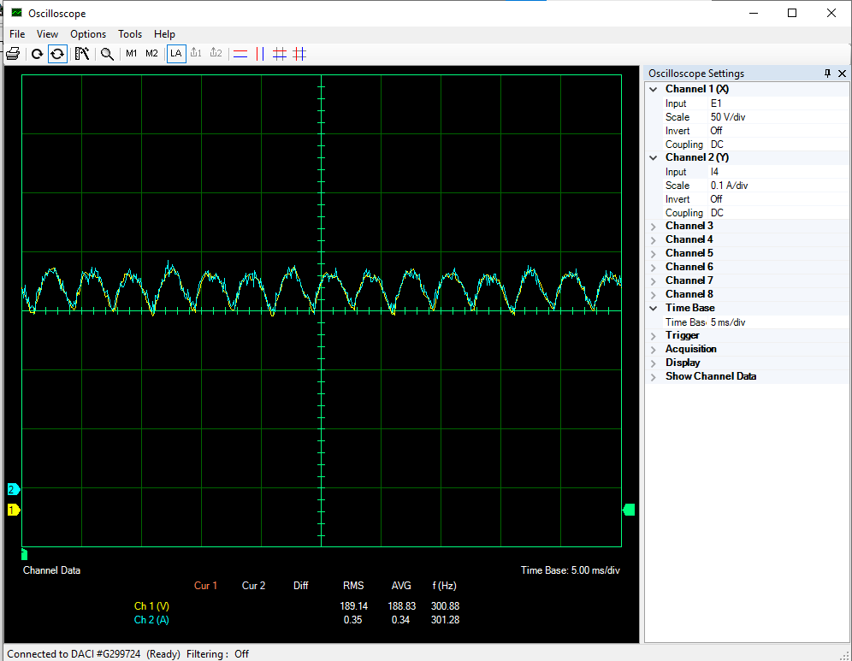

1. On the power supply, make sure that the voltage control knob is set to the 0 position, then set the main power switch to I (ON). Set the voltage control knob so that the voltage indicated by the power supply voltmeter is equal to 90% of the nominal line-to-neutral voltage.

Sketch the voltage and current waveforms displayed on the oscilloscope in Figure 7.

Ripple frequency: **300.1 Hz**



Figure 7. Voltage and current waveforms for the three-phase, full-wave rectifier.

1. Record the output voltage , current, and power of the rectifier circuit in the first row of the Table 2.

|  |  |  |  |  |
| --- | --- | --- | --- | --- |
| **Load Z1** | **Output Voltage**  **E1 dc** | **Output Current**  **I1 dc** | **Output Power**  **Po = E1 x I** | **Conduction**  **Angle** |
|  | **V** | **A** | **W** | **degrees** |
| (a) Resistive | 189.1 | 0.344 | 65.11 | Refer to Graph |
| (b) Inductive | 184 | 0.326 | 59.71 | Refer to Graph |

Table 2. Measurements for three-phase, full-wave rectifier circuit.

1. With the power off, change the load in the circuit to the inductive load Z1(b) i.e.

with R

Ω and L = 0.8 H. Repeat the procedure steps necessary to

complete the Table 2 and Figure 7.

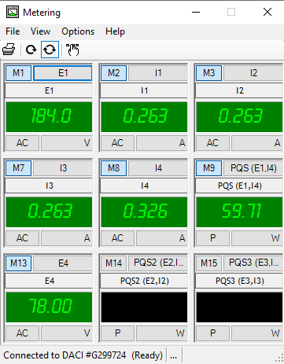

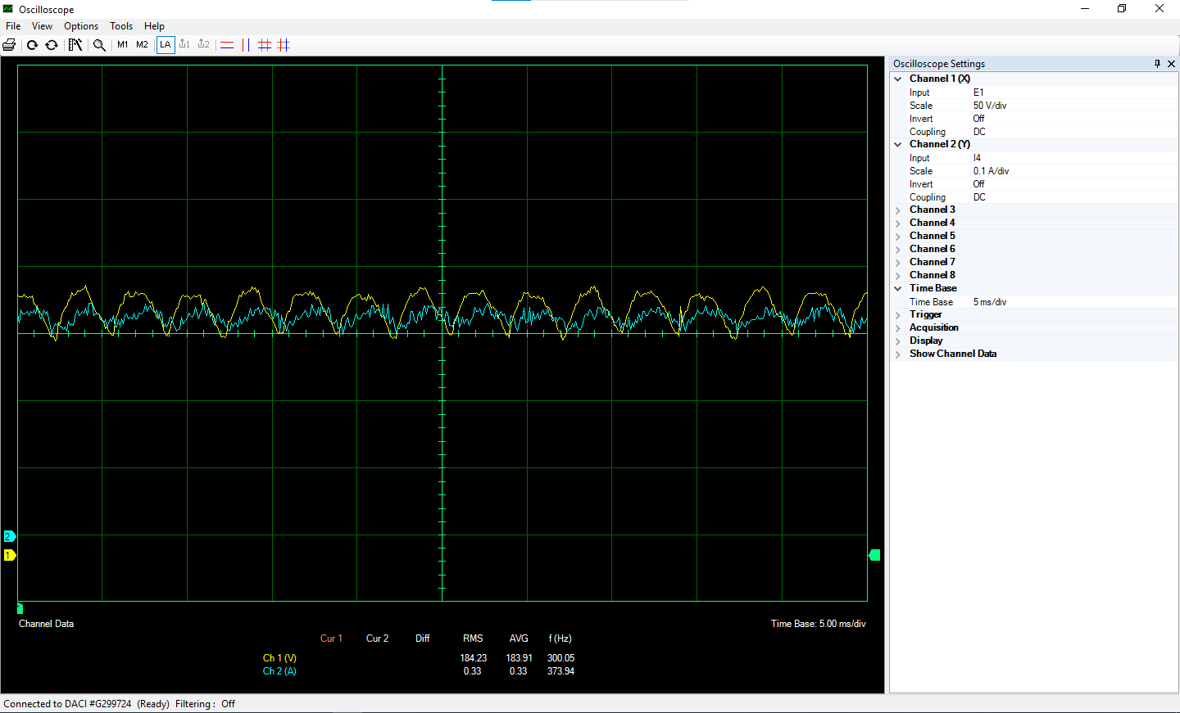

1. Compare the following characteristics of a three-phase, full-wave rectifier to those of a three-phase, half-wave rectifier.

Conduction angle:

Ripple frequency:

Average output voltage and power:

|  |  |  |
| --- | --- | --- |
|  | **Three Phase**  **Half Wave Rectifier** | **Three Phase**  **Full wave Rectifier** |
| **Diode Conduction angle:** | 120◦ | 60◦ |
| **Ripple Frequency** | 150 Hz | 300.1 Hz |
| **Average output voltage** | 233.3 V | 183.9 V |

|  |
| --- |
| **Diode Conduction Angle (Full wave three phase bridge rectifier)**  For three-phase uncontrolled rectification, the diodes conduct in matching pairs with each conduction path passing through two diodes in series. SO, a total of six rectifier diodes are required with commutation of the circuit taking place every 60o, or six times per cycle. full wave three phase rectifier conduction waveform |

1. Compare the output voltage of the circuit to the theoretical value.

Theoretical value: Eo = 1.35 ES = 609.21 V dc

Measured value: E1= 260.54 V

|  |
| --- |
| **Calculations:**  ERMS = 184.32 V  E speak= ERMS* V =260.54  Es = E speak * V (V line-line= sqrt 3* V phase)  Es = 451.269 V |

1. On the power supply, set the voltage control knob to the 0 position then set the main power switch to the O position.

|  |
| --- |
| **Conclusion:**    In this lab, we noticed the effect of uncontrolled rectifier on three phase source signals. Hardware implantation of Halfwave and full wave bridge rectifier circuit is implanted in the lab where we study the effect of circuit on the resistive and inductive load at load terminal. As diodes allow current to pass in one direction only, so we also studied the effect of conduction angle of diodes in halfwave rectifier as well as full wave rectifier. |